Art Wear Detroit – Darcel Deneau
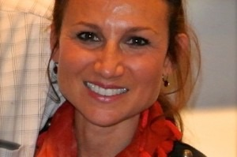
Adversity illuminated the importance of art for Darcel Deneau and without hesitation she redirected her life’s journey in pursuit of painting. In 2002, she earned a BFA from the College for Creative Studies. A native Detroiter, Deneau has been intrigued with painting images of the city for several years. Each painting is intended to comment on the city’s perceived image and represents a moment in the history of Detroit’s progression since the year 2000.
Deneau paints daily in her studio and is actively involved in the Detroit art community. She is currently serving as chairman of the board for the Detroit Artists Market, (DAM), and she is a member of the alumni council for the College for Creative Studies, (CCS). Since graduating twelve years ago she has produced an impressive body of work, exhibited in numerous juried and curated exhibitions, including 11 solo shows.
Deneau has earned a notable reputation for her Detroit landscapes and has been pursued for many commissions, including the 28th Detroit International Jazz Festival poster artwork, a large-scale Detroit landscape for the Hudson-Weber Foundation and a 29’ x 7’ mural for Garage Restaurant and Fuel Bar, in Northville, Michigan.
Deneau’s work has been widely collected by private collectors as well as corporate venues. Select collections include: Nathan Forbes, Matthew Cullen, Michael Farrell, Hudson-Weber Foundation, James Duffy, Peter Walsh of TLC, Mack Avenue Records, Ernst & Young, Gretchen Valade, Mark & Molly Valade, Skip Davis, Stan Dickson, University of Michigan, IAC Automotive, Marketing Associates, Ameriprise Financial, and Visteon Corporation.
Artwork
Shop / Darcel Deneau
View: 50 / 100 / All
Download Catalog

